**Contribution Plan and Timeline**

**Project Name:** Movie Recommendation

**Team Members:** Earl Hibbs, Jack Demtshuk, Nick Taweel, Ishaq Halimi

**Prepared By:** Earl Hibbs

**1: Team Members & Roles**

|  |  |  |  |
| --- | --- | --- | --- |
| **Member Name** | **Primary Responsibilities** | **Specific Tasks** | **Timeline/Deadline** |
| Earl Hibbs | Oversee Project / Assist with Backend | Implement Movie class, Start Recommender class, (Assist where needed) | 4/15/2025 |
| Jack Demtshuk | Tree System | Implement TreeNode / GenreTree | 4/15/2025 |
| Nick Taweel | Graph System | Implement MovieGraph | 4/15/2025 |
| Ishaq Halimi | Dataset | Implement DatasetLoader | 4/15/2025 |

**2: Collaborative Task and Timeline/Deadline**

|  |  |
| --- | --- |
| **Collaborative Task and Member Names** | **Timeline / Deadline** |
| Go over what GUI we should implement for our user interface (EVERYONE)  Go over the dataset that Ishaq provided and decide how we should incorporate it | 4/17/2025 |

**3: Data Collection**

We needed a dataset of movies for recommendation. This is the sample of the “cleaned_movies.csv” that Ishaq provided us:

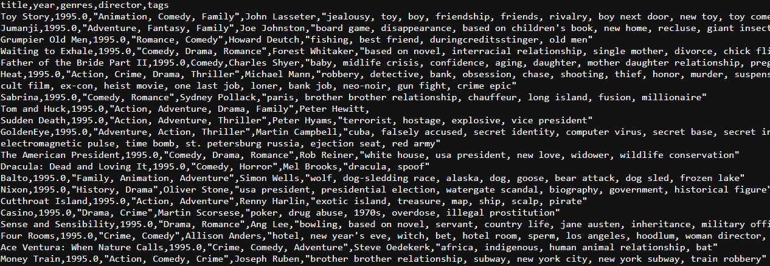The actual file is uploaded to GitHub.

**4: Completed Tasks**

|  |  |
| --- | --- |
| **Member Name** | **Task Completed** |
| Earl Hibbs | Assembled the GitHub, helped construct the Preliminary Report, constructed the finalized UML diagram, assigned tasks |
| Jack Demtshuk | Helped construct the preliminary report, researched the Tree class, documented and uploaded to docs |
| Nick Taweel | Helped construct the preliminary report, researched the Graph class, created docs for tags, documented and uploaded to docs |
| Ishaq Halimi | Researched the DatasetLoader class, found our dataset in a .csv file |